Aulas 3.5 - alguns parametros comuns a varios tipos de graficos

Elder Sodre

Wednesday, February 25, 2015

#### Preparando os dados

Para a aula de hoje, usaremos como exemplo alguns dados com os quais vocês já devem estar acostumados das últimas aulas.

setwd("C:\\Users\\Elder\\Desktop\\Minicurso Elementos de Linguagem R")  
  
#Dados do ecolagoas de 2008:  
ecolagoas <- read.csv2("ecolagoas2008.csv",na.strings="-",row.names=1)  
  
#Variáveis x e y:  
x <- 1:20  
set.seed(635)  
y <- 1:20 + rnorm(20,sd=3)  
  
#Variável a:  
set.seed(60)  
a <- rnorm(123)

Já aprendemos a criar gráficos básicos. Agora, vamos aprender a alterar sua aparência. Há alguns argumentos que são comuns a diversos tipos de gráficos.

#### Alterando o tipo e o tamanho dos pontos

O argumento pch permite alterar o tipo de ponto. Os valores de pch são definidos por números inteiros de 1 a 25. Por default, pch=1, que corresponde ao círculo vazado.

plot(x,y)

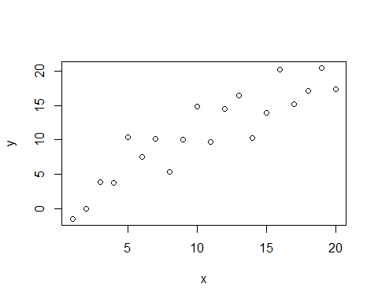

plot(x,y,pch=2)

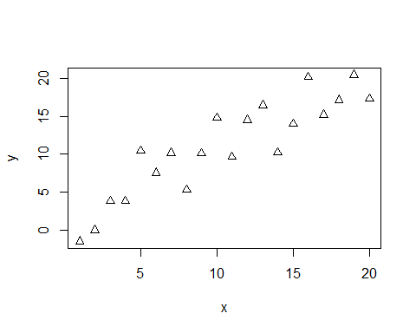

plot(x,y,pch=11)

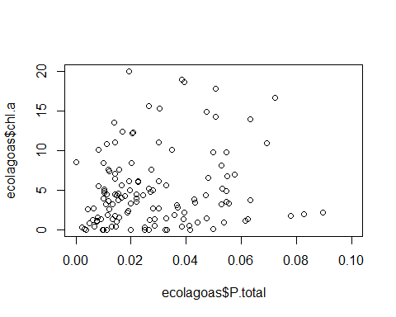

plot(x,y,pch=23)

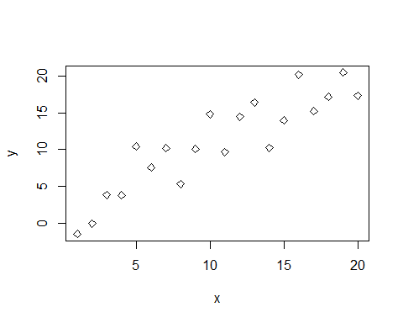

Curioso para ver todos os 25 tipos de pontos? Rode o código abaixo:

plot(x=1:25,y=rep(1,25),pch=1:25)

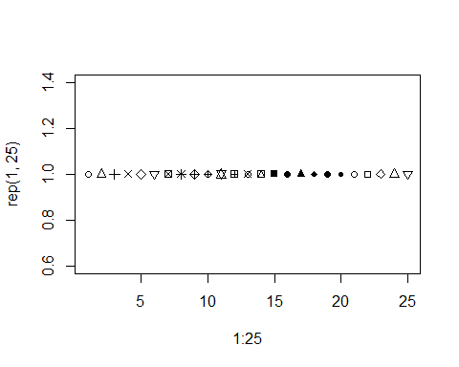

O argumento cex altera o tamanho do ponto. Quando não especificado, cex=1.

plot(x,y,cex=1)



plot(x,y,cex=0.5)

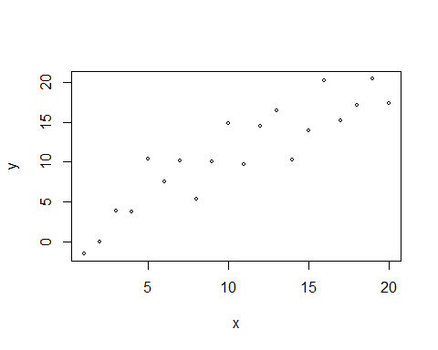

plot(x,y,cex=2)

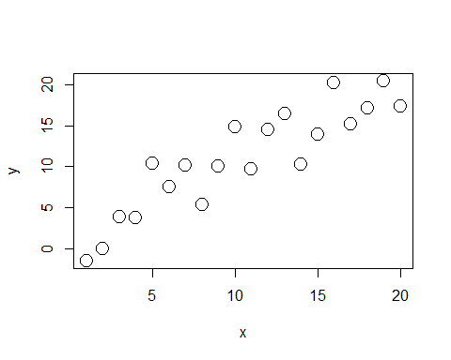

plot(x,y,cex=1.3,pch=8)

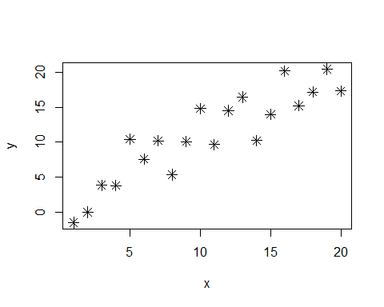

#### Alterando tipos e tamanhos de linhas

O argumento lty permite alterar o tipo de linha (cheia, pontilhada, tracejada...). O default é lty=1, que corresponde à linha cheia.

plot(x,y,type="l")

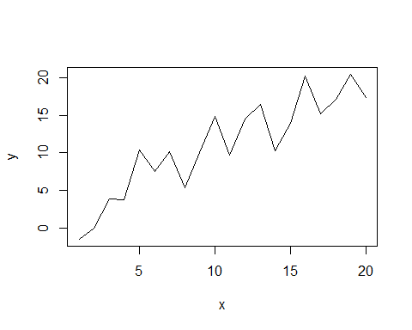

plot(x,y,type="l",lty=2)

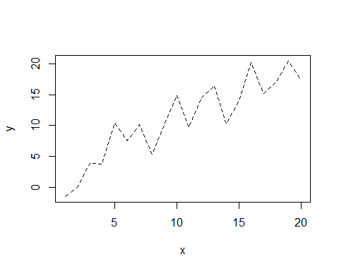

plot(x,y,type="l",lty=6)

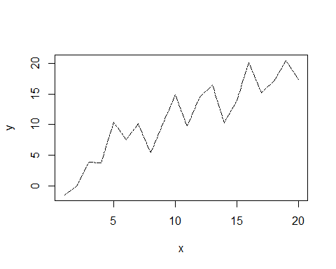

Há seis tipos de linhas disponíveis. Quer vê-los? Rode o código abaixo.

plot(x,y,xlim=c(0,5),ylim=c(0,7),type="n")  
for (i in 1:6) {  
 lines(x=-1:6,y=rep(i,8),lty=i)  
}

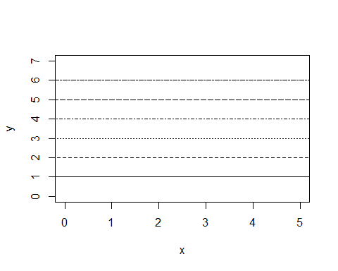

O argumento lwd altera a espessura da linha. Por default, lwd=1.

plot(x,y,type="l",lwd=1)



plot(x,y,type="l",lwd=2)

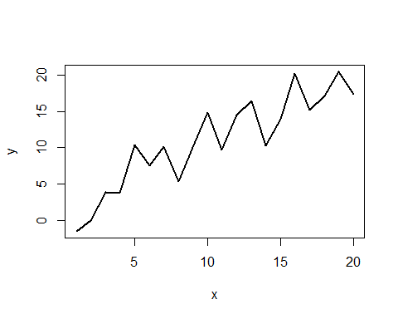

plot(x,y,type="l",lty=4,lwd=5)

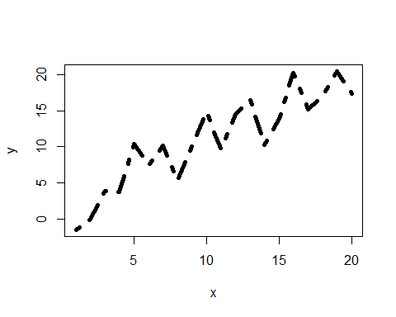

#### Cores

As cores dos gráficos podem ser escolhidas por meio do argumento col. O argumento col pode ser definido de 3 formas diferentes:

* 1- Por números inteiros de 1 a 8
* 2- Por uma sequência de caracteres (nome das cores em inglês)
* 3- Código RGB

1- A cor pode ser definida por números inteiros de 1 a 8, de forma semelhante à escolha dos tipos de pontos ou tipos de linhas.

plot(x,y,pch=15,cex=1.3,col=3)

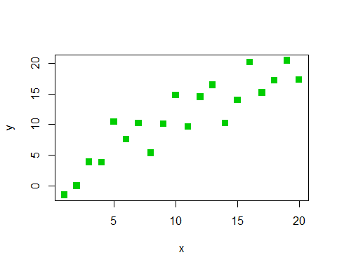

plot(x,y,pch=15,cex=1.3,col=7)

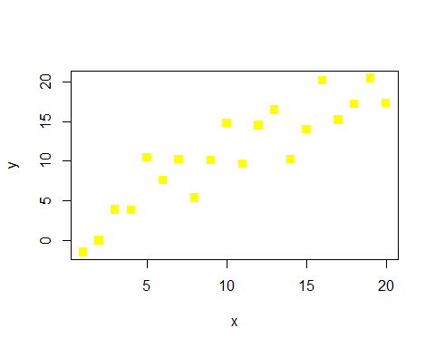

Use o código abaixo para ver as 8 cores possíveis:

plot(x=1:8,y=rep(1,8),pch=16,cex=5,col=1:8)

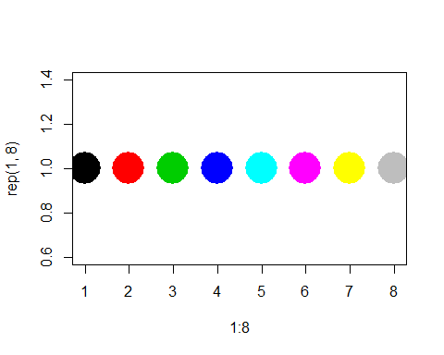

2- A cor também pode ser definida por seu nome em inglês.

plot(x,y,col="blue")

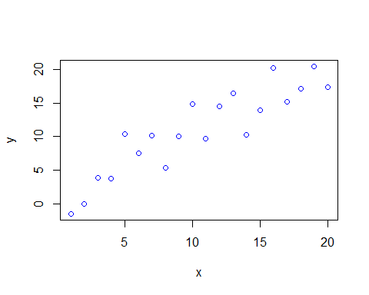

plot(x,y,col="lightgreen")

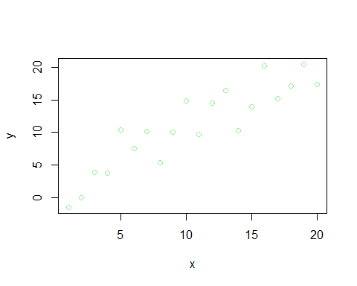

hist(a,col="red")

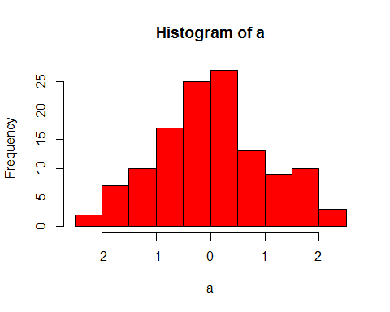

Para conferir todas as cores possíveis, use a função colors().

colors()

## [1] "white" "aliceblue" "antiquewhite"   
## [4] "antiquewhite1" "antiquewhite2" "antiquewhite3"   
## [7] "antiquewhite4" "aquamarine" "aquamarine1"   
## [10] "aquamarine2" "aquamarine3" "aquamarine4"   
## [13] "azure" "azure1" "azure2"   
## [16] "azure3" "azure4" "beige"   
## [19] "bisque" "bisque1" "bisque2"   
## [22] "bisque3" "bisque4" "black"   
## [25] "blanchedalmond" "blue" "blue1"   
## [28] "blue2" "blue3" "blue4"   
## [31] "blueviolet" "brown" "brown1"   
## [34] "brown2" "brown3" "brown4"   
## [37] "burlywood" "burlywood1" "burlywood2"   
## [40] "burlywood3" "burlywood4" "cadetblue"   
## [43] "cadetblue1" "cadetblue2" "cadetblue3"   
## [46] "cadetblue4" "chartreuse" "chartreuse1"   
## [49] "chartreuse2" "chartreuse3" "chartreuse4"   
## [52] "chocolate" "chocolate1" "chocolate2"   
## [55] "chocolate3" "chocolate4" "coral"   
## [58] "coral1" "coral2" "coral3"   
## [61] "coral4" "cornflowerblue" "cornsilk"   
## [64] "cornsilk1" "cornsilk2" "cornsilk3"   
## [67] "cornsilk4" "cyan" "cyan1"   
## [70] "cyan2" "cyan3" "cyan4"   
## [73] "darkblue" "darkcyan" "darkgoldenrod"   
## [76] "darkgoldenrod1" "darkgoldenrod2" "darkgoldenrod3"   
## [79] "darkgoldenrod4" "darkgray" "darkgreen"   
## [82] "darkgrey" "darkkhaki" "darkmagenta"   
## [85] "darkolivegreen" "darkolivegreen1" "darkolivegreen2"   
## [88] "darkolivegreen3" "darkolivegreen4" "darkorange"   
## [91] "darkorange1" "darkorange2" "darkorange3"   
## [94] "darkorange4" "darkorchid" "darkorchid1"   
## [97] "darkorchid2" "darkorchid3" "darkorchid4"   
## [100] "darkred" "darksalmon" "darkseagreen"   
## [103] "darkseagreen1" "darkseagreen2" "darkseagreen3"   
## [106] "darkseagreen4" "darkslateblue" "darkslategray"   
## [109] "darkslategray1" "darkslategray2" "darkslategray3"   
## [112] "darkslategray4" "darkslategrey" "darkturquoise"   
## [115] "darkviolet" "deeppink" "deeppink1"   
## [118] "deeppink2" "deeppink3" "deeppink4"   
## [121] "deepskyblue" "deepskyblue1" "deepskyblue2"   
## [124] "deepskyblue3" "deepskyblue4" "dimgray"   
## [127] "dimgrey" "dodgerblue" "dodgerblue1"   
## [130] "dodgerblue2" "dodgerblue3" "dodgerblue4"   
## [133] "firebrick" "firebrick1" "firebrick2"   
## [136] "firebrick3" "firebrick4" "floralwhite"   
## [139] "forestgreen" "gainsboro" "ghostwhite"   
## [142] "gold" "gold1" "gold2"   
## [145] "gold3" "gold4" "goldenrod"   
## [148] "goldenrod1" "goldenrod2" "goldenrod3"   
## [151] "goldenrod4" "gray" "gray0"   
## [154] "gray1" "gray2" "gray3"   
## [157] "gray4" "gray5" "gray6"   
## [160] "gray7" "gray8" "gray9"   
## [163] "gray10" "gray11" "gray12"   
## [166] "gray13" "gray14" "gray15"   
## [169] "gray16" "gray17" "gray18"   
## [172] "gray19" "gray20" "gray21"   
## [175] "gray22" "gray23" "gray24"   
## [178] "gray25" "gray26" "gray27"   
## [181] "gray28" "gray29" "gray30"   
## [184] "gray31" "gray32" "gray33"   
## [187] "gray34" "gray35" "gray36"   
## [190] "gray37" "gray38" "gray39"   
## [193] "gray40" "gray41" "gray42"   
## [196] "gray43" "gray44" "gray45"   
## [199] "gray46" "gray47" "gray48"   
## [202] "gray49" "gray50" "gray51"   
## [205] "gray52" "gray53" "gray54"   
## [208] "gray55" "gray56" "gray57"   
## [211] "gray58" "gray59" "gray60"   
## [214] "gray61" "gray62" "gray63"   
## [217] "gray64" "gray65" "gray66"   
## [220] "gray67" "gray68" "gray69"   
## [223] "gray70" "gray71" "gray72"   
## [226] "gray73" "gray74" "gray75"   
## [229] "gray76" "gray77" "gray78"   
## [232] "gray79" "gray80" "gray81"   
## [235] "gray82" "gray83" "gray84"   
## [238] "gray85" "gray86" "gray87"   
## [241] "gray88" "gray89" "gray90"   
## [244] "gray91" "gray92" "gray93"   
## [247] "gray94" "gray95" "gray96"   
## [250] "gray97" "gray98" "gray99"   
## [253] "gray100" "green" "green1"   
## [256] "green2" "green3" "green4"   
## [259] "greenyellow" "grey" "grey0"   
## [262] "grey1" "grey2" "grey3"   
## [265] "grey4" "grey5" "grey6"   
## [268] "grey7" "grey8" "grey9"   
## [271] "grey10" "grey11" "grey12"   
## [274] "grey13" "grey14" "grey15"   
## [277] "grey16" "grey17" "grey18"   
## [280] "grey19" "grey20" "grey21"   
## [283] "grey22" "grey23" "grey24"   
## [286] "grey25" "grey26" "grey27"   
## [289] "grey28" "grey29" "grey30"   
## [292] "grey31" "grey32" "grey33"   
## [295] "grey34" "grey35" "grey36"   
## [298] "grey37" "grey38" "grey39"   
## [301] "grey40" "grey41" "grey42"   
## [304] "grey43" "grey44" "grey45"   
## [307] "grey46" "grey47" "grey48"   
## [310] "grey49" "grey50" "grey51"   
## [313] "grey52" "grey53" "grey54"   
## [316] "grey55" "grey56" "grey57"   
## [319] "grey58" "grey59" "grey60"   
## [322] "grey61" "grey62" "grey63"   
## [325] "grey64" "grey65" "grey66"   
## [328] "grey67" "grey68" "grey69"   
## [331] "grey70" "grey71" "grey72"   
## [334] "grey73" "grey74" "grey75"   
## [337] "grey76" "grey77" "grey78"   
## [340] "grey79" "grey80" "grey81"   
## [343] "grey82" "grey83" "grey84"   
## [346] "grey85" "grey86" "grey87"   
## [349] "grey88" "grey89" "grey90"   
## [352] "grey91" "grey92" "grey93"   
## [355] "grey94" "grey95" "grey96"   
## [358] "grey97" "grey98" "grey99"   
## [361] "grey100" "honeydew" "honeydew1"   
## [364] "honeydew2" "honeydew3" "honeydew4"   
## [367] "hotpink" "hotpink1" "hotpink2"   
## [370] "hotpink3" "hotpink4" "indianred"   
## [373] "indianred1" "indianred2" "indianred3"   
## [376] "indianred4" "ivory" "ivory1"   
## [379] "ivory2" "ivory3" "ivory4"   
## [382] "khaki" "khaki1" "khaki2"   
## [385] "khaki3" "khaki4" "lavender"   
## [388] "lavenderblush" "lavenderblush1" "lavenderblush2"   
## [391] "lavenderblush3" "lavenderblush4" "lawngreen"   
## [394] "lemonchiffon" "lemonchiffon1" "lemonchiffon2"   
## [397] "lemonchiffon3" "lemonchiffon4" "lightblue"   
## [400] "lightblue1" "lightblue2" "lightblue3"   
## [403] "lightblue4" "lightcoral" "lightcyan"   
## [406] "lightcyan1" "lightcyan2" "lightcyan3"   
## [409] "lightcyan4" "lightgoldenrod" "lightgoldenrod1"   
## [412] "lightgoldenrod2" "lightgoldenrod3" "lightgoldenrod4"   
## [415] "lightgoldenrodyellow" "lightgray" "lightgreen"   
## [418] "lightgrey" "lightpink" "lightpink1"   
## [421] "lightpink2" "lightpink3" "lightpink4"   
## [424] "lightsalmon" "lightsalmon1" "lightsalmon2"   
## [427] "lightsalmon3" "lightsalmon4" "lightseagreen"   
## [430] "lightskyblue" "lightskyblue1" "lightskyblue2"   
## [433] "lightskyblue3" "lightskyblue4" "lightslateblue"   
## [436] "lightslategray" "lightslategrey" "lightsteelblue"   
## [439] "lightsteelblue1" "lightsteelblue2" "lightsteelblue3"   
## [442] "lightsteelblue4" "lightyellow" "lightyellow1"   
## [445] "lightyellow2" "lightyellow3" "lightyellow4"   
## [448] "limegreen" "linen" "magenta"   
## [451] "magenta1" "magenta2" "magenta3"   
## [454] "magenta4" "maroon" "maroon1"   
## [457] "maroon2" "maroon3" "maroon4"   
## [460] "mediumaquamarine" "mediumblue" "mediumorchid"   
## [463] "mediumorchid1" "mediumorchid2" "mediumorchid3"   
## [466] "mediumorchid4" "mediumpurple" "mediumpurple1"   
## [469] "mediumpurple2" "mediumpurple3" "mediumpurple4"   
## [472] "mediumseagreen" "mediumslateblue" "mediumspringgreen"   
## [475] "mediumturquoise" "mediumvioletred" "midnightblue"   
## [478] "mintcream" "mistyrose" "mistyrose1"   
## [481] "mistyrose2" "mistyrose3" "mistyrose4"   
## [484] "moccasin" "navajowhite" "navajowhite1"   
## [487] "navajowhite2" "navajowhite3" "navajowhite4"   
## [490] "navy" "navyblue" "oldlace"   
## [493] "olivedrab" "olivedrab1" "olivedrab2"   
## [496] "olivedrab3" "olivedrab4" "orange"   
## [499] "orange1" "orange2" "orange3"   
## [502] "orange4" "orangered" "orangered1"   
## [505] "orangered2" "orangered3" "orangered4"   
## [508] "orchid" "orchid1" "orchid2"   
## [511] "orchid3" "orchid4" "palegoldenrod"   
## [514] "palegreen" "palegreen1" "palegreen2"   
## [517] "palegreen3" "palegreen4" "paleturquoise"   
## [520] "paleturquoise1" "paleturquoise2" "paleturquoise3"   
## [523] "paleturquoise4" "palevioletred" "palevioletred1"   
## [526] "palevioletred2" "palevioletred3" "palevioletred4"   
## [529] "papayawhip" "peachpuff" "peachpuff1"   
## [532] "peachpuff2" "peachpuff3" "peachpuff4"   
## [535] "peru" "pink" "pink1"   
## [538] "pink2" "pink3" "pink4"   
## [541] "plum" "plum1" "plum2"   
## [544] "plum3" "plum4" "powderblue"   
## [547] "purple" "purple1" "purple2"   
## [550] "purple3" "purple4" "red"   
## [553] "red1" "red2" "red3"   
## [556] "red4" "rosybrown" "rosybrown1"   
## [559] "rosybrown2" "rosybrown3" "rosybrown4"   
## [562] "royalblue" "royalblue1" "royalblue2"   
## [565] "royalblue3" "royalblue4" "saddlebrown"   
## [568] "salmon" "salmon1" "salmon2"   
## [571] "salmon3" "salmon4" "sandybrown"   
## [574] "seagreen" "seagreen1" "seagreen2"   
## [577] "seagreen3" "seagreen4" "seashell"   
## [580] "seashell1" "seashell2" "seashell3"   
## [583] "seashell4" "sienna" "sienna1"   
## [586] "sienna2" "sienna3" "sienna4"   
## [589] "skyblue" "skyblue1" "skyblue2"   
## [592] "skyblue3" "skyblue4" "slateblue"   
## [595] "slateblue1" "slateblue2" "slateblue3"   
## [598] "slateblue4" "slategray" "slategray1"   
## [601] "slategray2" "slategray3" "slategray4"   
## [604] "slategrey" "snow" "snow1"   
## [607] "snow2" "snow3" "snow4"   
## [610] "springgreen" "springgreen1" "springgreen2"   
## [613] "springgreen3" "springgreen4" "steelblue"   
## [616] "steelblue1" "steelblue2" "steelblue3"   
## [619] "steelblue4" "tan" "tan1"   
## [622] "tan2" "tan3" "tan4"   
## [625] "thistle" "thistle1" "thistle2"   
## [628] "thistle3" "thistle4" "tomato"   
## [631] "tomato1" "tomato2" "tomato3"   
## [634] "tomato4" "turquoise" "turquoise1"   
## [637] "turquoise2" "turquoise3" "turquoise4"   
## [640] "violet" "violetred" "violetred1"   
## [643] "violetred2" "violetred3" "violetred4"   
## [646] "wheat" "wheat1" "wheat2"   
## [649] "wheat3" "wheat4" "whitesmoke"   
## [652] "yellow" "yellow1" "yellow2"   
## [655] "yellow3" "yellow4" "yellowgreen"

colors(distinct=T) #Elimina as cores idênticas

## [1] "white" "aliceblue" "antiquewhite"   
## [4] "antiquewhite1" "antiquewhite2" "antiquewhite3"   
## [7] "antiquewhite4" "aquamarine" "aquamarine2"   
## [10] "aquamarine3" "aquamarine4" "azure"   
## [13] "azure2" "azure3" "azure4"   
## [16] "beige" "bisque" "bisque2"   
## [19] "bisque3" "bisque4" "black"   
## [22] "blanchedalmond" "blue" "blue2"   
## [25] "blue3" "blue4" "blueviolet"   
## [28] "brown" "brown1" "brown2"   
## [31] "brown3" "brown4" "burlywood"   
## [34] "burlywood1" "burlywood2" "burlywood3"   
## [37] "burlywood4" "cadetblue" "cadetblue1"   
## [40] "cadetblue2" "cadetblue3" "cadetblue4"   
## [43] "chartreuse" "chartreuse2" "chartreuse3"   
## [46] "chartreuse4" "chocolate" "chocolate1"   
## [49] "chocolate2" "chocolate3" "chocolate4"   
## [52] "coral" "coral1" "coral2"   
## [55] "coral3" "coral4" "cornflowerblue"   
## [58] "cornsilk" "cornsilk2" "cornsilk3"   
## [61] "cornsilk4" "cyan" "cyan2"   
## [64] "cyan3" "cyan4" "darkgoldenrod"   
## [67] "darkgoldenrod1" "darkgoldenrod2" "darkgoldenrod3"   
## [70] "darkgoldenrod4" "darkgray" "darkgreen"   
## [73] "darkkhaki" "darkmagenta" "darkolivegreen"   
## [76] "darkolivegreen1" "darkolivegreen2" "darkolivegreen3"   
## [79] "darkolivegreen4" "darkorange" "darkorange1"   
## [82] "darkorange2" "darkorange3" "darkorange4"   
## [85] "darkorchid" "darkorchid1" "darkorchid2"   
## [88] "darkorchid3" "darkorchid4" "darkred"   
## [91] "darksalmon" "darkseagreen" "darkseagreen1"   
## [94] "darkseagreen2" "darkseagreen3" "darkseagreen4"   
## [97] "darkslateblue" "darkslategray" "darkslategray1"   
## [100] "darkslategray2" "darkslategray3" "darkslategray4"   
## [103] "darkturquoise" "darkviolet" "deeppink"   
## [106] "deeppink2" "deeppink3" "deeppink4"   
## [109] "deepskyblue" "deepskyblue2" "deepskyblue3"   
## [112] "deepskyblue4" "dimgray" "dodgerblue"   
## [115] "dodgerblue2" "dodgerblue3" "dodgerblue4"   
## [118] "firebrick" "firebrick1" "firebrick2"   
## [121] "firebrick3" "firebrick4" "floralwhite"   
## [124] "forestgreen" "gainsboro" "ghostwhite"   
## [127] "gold" "gold2" "gold3"   
## [130] "gold4" "goldenrod" "goldenrod1"   
## [133] "goldenrod2" "goldenrod3" "goldenrod4"   
## [136] "gray" "gray1" "gray2"   
## [139] "gray3" "gray4" "gray5"   
## [142] "gray6" "gray7" "gray8"   
## [145] "gray9" "gray10" "gray11"   
## [148] "gray12" "gray13" "gray14"   
## [151] "gray15" "gray16" "gray17"   
## [154] "gray18" "gray19" "gray20"   
## [157] "gray21" "gray22" "gray23"   
## [160] "gray24" "gray25" "gray26"   
## [163] "gray27" "gray28" "gray29"   
## [166] "gray30" "gray31" "gray32"   
## [169] "gray33" "gray34" "gray35"   
## [172] "gray36" "gray37" "gray38"   
## [175] "gray39" "gray40" "gray42"   
## [178] "gray43" "gray44" "gray45"   
## [181] "gray46" "gray47" "gray48"   
## [184] "gray49" "gray50" "gray51"   
## [187] "gray52" "gray53" "gray54"   
## [190] "gray55" "gray56" "gray57"   
## [193] "gray58" "gray59" "gray60"   
## [196] "gray61" "gray62" "gray63"   
## [199] "gray64" "gray65" "gray66"   
## [202] "gray67" "gray68" "gray69"   
## [205] "gray70" "gray71" "gray72"   
## [208] "gray73" "gray74" "gray75"   
## [211] "gray76" "gray77" "gray78"   
## [214] "gray79" "gray80" "gray81"   
## [217] "gray82" "gray83" "gray84"   
## [220] "gray85" "gray86" "gray87"   
## [223] "gray88" "gray89" "gray90"   
## [226] "gray91" "gray92" "gray93"   
## [229] "gray94" "gray95" "gray96"   
## [232] "gray97" "gray98" "gray99"   
## [235] "green" "green2" "green3"   
## [238] "green4" "greenyellow" "honeydew"   
## [241] "honeydew2" "honeydew3" "honeydew4"   
## [244] "hotpink" "hotpink1" "hotpink2"   
## [247] "hotpink3" "hotpink4" "indianred"   
## [250] "indianred1" "indianred2" "indianred3"   
## [253] "indianred4" "ivory" "ivory2"   
## [256] "ivory3" "ivory4" "khaki"   
## [259] "khaki1" "khaki2" "khaki3"   
## [262] "khaki4" "lavender" "lavenderblush"   
## [265] "lavenderblush2" "lavenderblush3" "lavenderblush4"   
## [268] "lawngreen" "lemonchiffon" "lemonchiffon2"   
## [271] "lemonchiffon3" "lemonchiffon4" "lightblue"   
## [274] "lightblue1" "lightblue2" "lightblue3"   
## [277] "lightblue4" "lightcoral" "lightcyan"   
## [280] "lightcyan2" "lightcyan3" "lightcyan4"   
## [283] "lightgoldenrod" "lightgoldenrod1" "lightgoldenrod2"   
## [286] "lightgoldenrod3" "lightgoldenrod4" "lightgoldenrodyellow"  
## [289] "lightgray" "lightgreen" "lightpink"   
## [292] "lightpink1" "lightpink2" "lightpink3"   
## [295] "lightpink4" "lightsalmon" "lightsalmon2"   
## [298] "lightsalmon3" "lightsalmon4" "lightseagreen"   
## [301] "lightskyblue" "lightskyblue1" "lightskyblue2"   
## [304] "lightskyblue3" "lightskyblue4" "lightslateblue"   
## [307] "lightslategray" "lightsteelblue" "lightsteelblue1"   
## [310] "lightsteelblue2" "lightsteelblue3" "lightsteelblue4"   
## [313] "lightyellow" "lightyellow2" "lightyellow3"   
## [316] "lightyellow4" "limegreen" "linen"   
## [319] "magenta" "magenta2" "magenta3"   
## [322] "maroon" "maroon1" "maroon2"   
## [325] "maroon3" "maroon4" "mediumorchid"   
## [328] "mediumorchid1" "mediumorchid2" "mediumorchid3"   
## [331] "mediumorchid4" "mediumpurple" "mediumpurple1"   
## [334] "mediumpurple2" "mediumpurple3" "mediumpurple4"   
## [337] "mediumseagreen" "mediumslateblue" "mediumspringgreen"   
## [340] "mediumturquoise" "mediumvioletred" "midnightblue"   
## [343] "mintcream" "mistyrose" "mistyrose2"   
## [346] "mistyrose3" "mistyrose4" "moccasin"   
## [349] "navajowhite" "navajowhite2" "navajowhite3"   
## [352] "navajowhite4" "navy" "oldlace"   
## [355] "olivedrab" "olivedrab1" "olivedrab2"   
## [358] "olivedrab3" "olivedrab4" "orange"   
## [361] "orange2" "orange3" "orange4"   
## [364] "orangered" "orangered2" "orangered3"   
## [367] "orangered4" "orchid" "orchid1"   
## [370] "orchid2" "orchid3" "orchid4"   
## [373] "palegoldenrod" "palegreen" "palegreen1"   
## [376] "palegreen3" "palegreen4" "paleturquoise"   
## [379] "paleturquoise1" "paleturquoise2" "paleturquoise3"   
## [382] "paleturquoise4" "palevioletred" "palevioletred1"   
## [385] "palevioletred2" "palevioletred3" "palevioletred4"   
## [388] "papayawhip" "peachpuff" "peachpuff2"   
## [391] "peachpuff3" "peachpuff4" "peru"   
## [394] "pink" "pink1" "pink2"   
## [397] "pink3" "pink4" "plum"   
## [400] "plum1" "plum2" "plum3"   
## [403] "plum4" "powderblue" "purple"   
## [406] "purple1" "purple2" "purple3"   
## [409] "purple4" "red" "red2"   
## [412] "red3" "rosybrown" "rosybrown1"   
## [415] "rosybrown2" "rosybrown3" "rosybrown4"   
## [418] "royalblue" "royalblue1" "royalblue2"   
## [421] "royalblue3" "royalblue4" "salmon"   
## [424] "salmon1" "salmon2" "salmon3"   
## [427] "salmon4" "sandybrown" "seagreen"   
## [430] "seagreen1" "seagreen2" "seagreen3"   
## [433] "seashell" "seashell2" "seashell3"   
## [436] "seashell4" "sienna" "sienna1"   
## [439] "sienna2" "sienna3" "sienna4"   
## [442] "skyblue" "skyblue1" "skyblue2"   
## [445] "skyblue3" "skyblue4" "slateblue"   
## [448] "slateblue1" "slateblue2" "slateblue3"   
## [451] "slateblue4" "slategray" "slategray1"   
## [454] "slategray2" "slategray3" "slategray4"   
## [457] "snow" "snow2" "snow3"   
## [460] "snow4" "springgreen" "springgreen2"   
## [463] "springgreen3" "springgreen4" "steelblue"   
## [466] "steelblue1" "steelblue2" "steelblue3"   
## [469] "steelblue4" "tan" "tan1"   
## [472] "tan2" "tan4" "thistle"   
## [475] "thistle1" "thistle2" "thistle3"   
## [478] "thistle4" "tomato" "tomato2"   
## [481] "tomato3" "tomato4" "turquoise"   
## [484] "turquoise1" "turquoise2" "turquoise3"   
## [487] "turquoise4" "violet" "violetred"   
## [490] "violetred1" "violetred2" "violetred3"   
## [493] "violetred4" "wheat" "wheat1"   
## [496] "wheat2" "wheat3" "wheat4"   
## [499] "yellow" "yellow2" "yellow3"   
## [502] "yellow4"

Com isso, vemos que há 502 cores distintas possíveis! Algumas tem nomes normais, como "blue", "yellow, "green". Mas muitas tem nomes bem peculiares, como "darkgoldenrod","firebrick2" e "papayawhip".A função example() provê uma interessante demonstração das cores. Use-a no seu R.

example(colors)

boxplot(ecolagoas$secchi~ecolagoas$lagoa,col="maroon4")

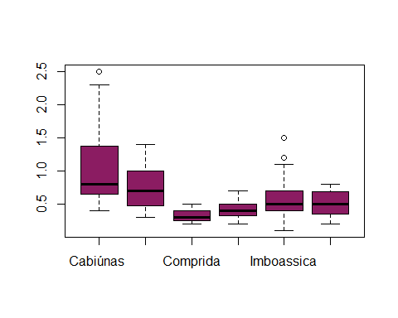

barplot(c(10,4,12,9),col="navy")

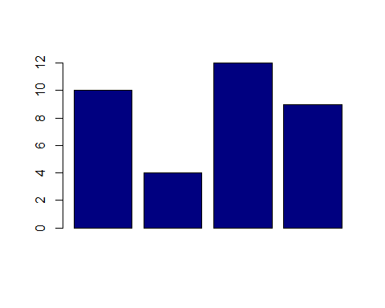

3- Código RGB

O código RGB contrói cores a partir das três cores básicas que o olho humano enxerga: vermelho, verde e azul. Cada cor básica adquire um cavlor de 0 a 255, num total de 256 x 256 x 256 = 16777216 cores possíveis. Não vou entrar em detalhes aqui; maiores detalhes podem ser vistos em diversos sites da internet, entre eles:

<http://www.rapidtables.com/web/color/RGB_Color.htm>

Alguns exemplos:

barplot(c(10,4,12,9),col="#32E6B4")

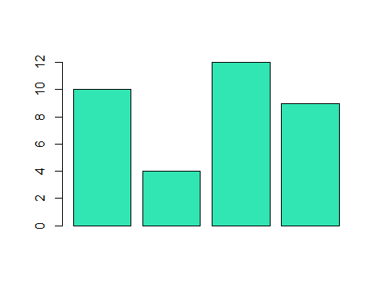

plot(x,y,pch=16,col="#336600")

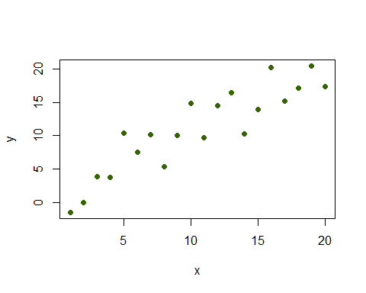

#### Trabalhando com diversas cores

Vamos refazer o gráfico de pizza das eleições:

eleições <- c(Juca=789,Maria=502,Zé=95,Rosinha=636,"Ana Júlia"=261)  
  
pie(eleições)

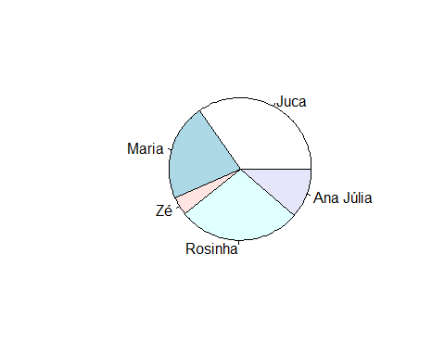

Quando escolhemos apenas uma cor, todo o gráfico fica com a mesma cor.

pie(eleições,col="gold")

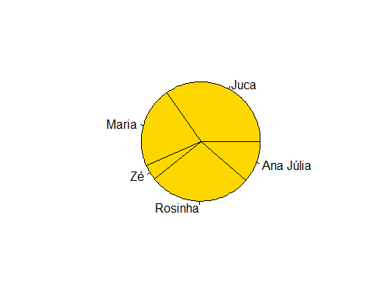

Para que o gráfico tenha cores diferentes, basta usar um vetor de cores:

pie(eleições,col=c(2,5,8,3,6))

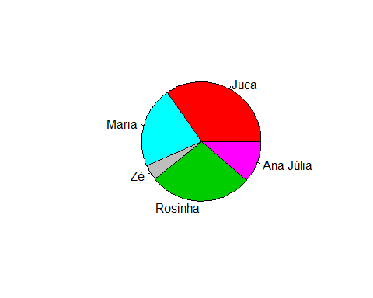

plot(x,y,col=c("green","yellow"))

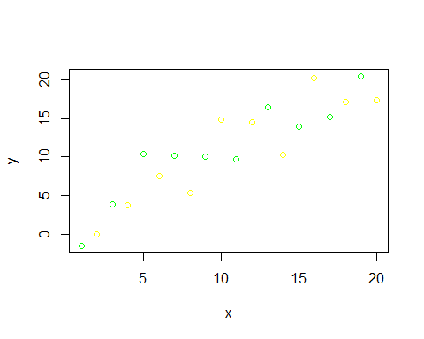

Porém, há algumas funções que escolhem as cores automaticamente para você.

rainbow(n)

A função acima escolhe automaticamente n cores espaçadas igualmente da palheta de cores escolhidas (arco-íris, no caso).

rainbow(3) #A função retorna códigos RGB.

## [1] "#FF0000FF" "#00FF00FF" "#0000FFFF"

Vamos ver esta e outras funções em ação:

pie(eleições,col=rainbow(5))

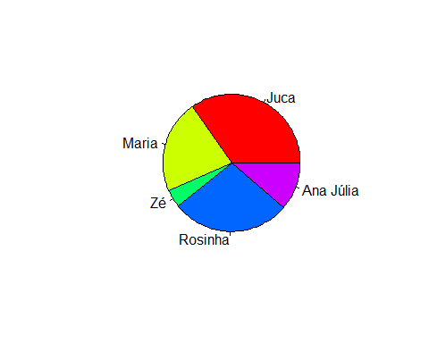

barplot(c(10,4,12,9),col=heat.colors(4))

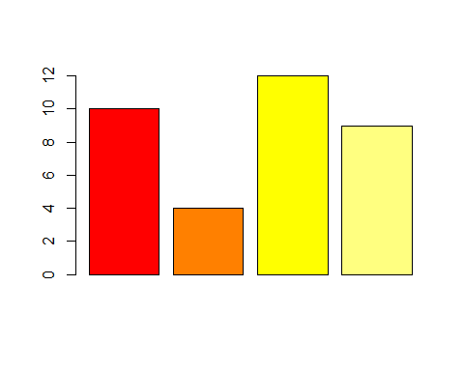

plot(x,y,pch=16,cex=2,col=terrain.colors(20))

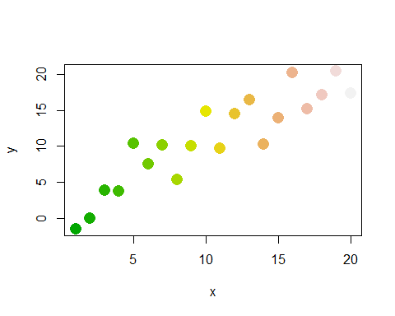

pie(eleições,col=topo.colors(5))

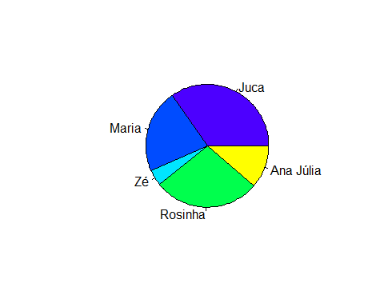

pie(eleições,col=cm.colors(5))

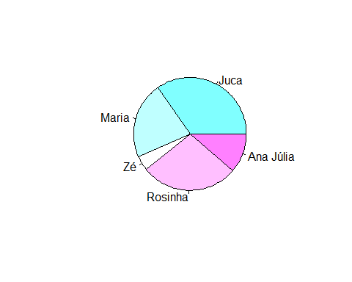

#### Título e subtítulo dos gráficos

O argumento main cria um título para o gráfico, enquanto o argumento sub cria o subtítulo.

plot(x,y,main="Título",sub="Subtítulo")

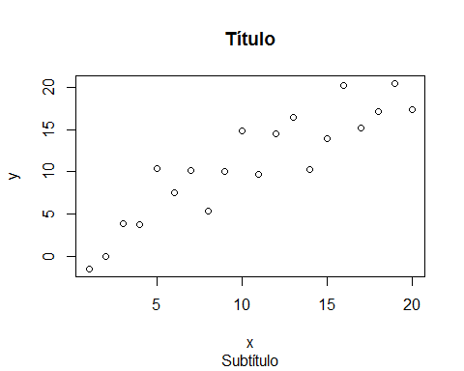

plot(x,y,main="Gráfico de dispersão")

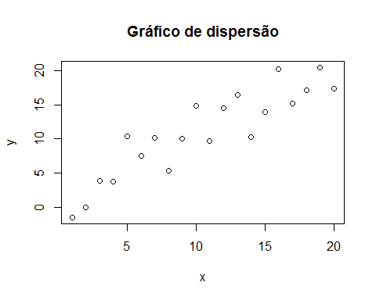

#### Nome dos eixos

xlab e ylab alteram o nome dos eixos.

plot(x,y,xlab="Eixo X", ylab="Eixo Y")

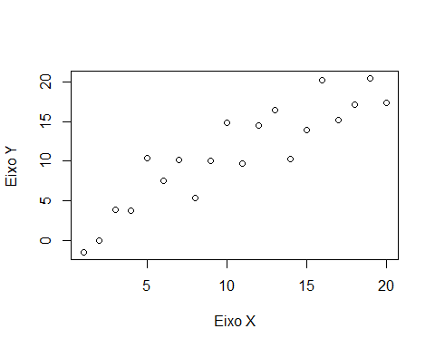

Vamos plotar as concentrações de clorofila a pelo fósforo total nas lagoas costeiras:

plot(ecolagoas$P.total,ecolagoas$chl.a)

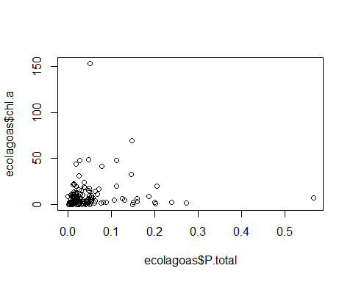

plot(ecolagoas$P.total,ecolagoas$chl.a,xlab="Fósforo Total",ylab="Clorofila a")

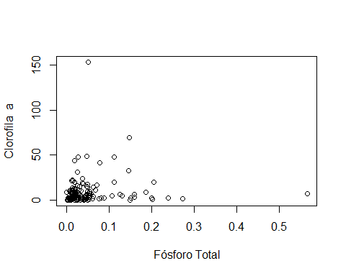

#Melhor assim, não?

#### Definindo os intervalos dos eixos x e y.

No gráfico acima, outliers fazem com que a maioria dos pontos fique espremida e difícil de ver. Os parâmetros xlim e ylim permitem alterar os intervalos dos eixos. Eles funcionam assim: xlim/ylim=c(min,max)

plot(ecolagoas$P.total,ecolagoas$chl.a)



plot(ecolagoas$P.total,ecolagoas$chl.a,xlim=c(0,0.3),ylim=c(0,50))

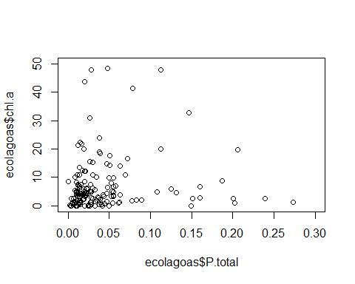 No gráfico Acima, o eixo x ficou definido entre 0 e 0.3, e o eixo y entre 0 e 50. Isto deixou alguns pontos fora do gráfico, mas facilitou a visualização.

Talvez, fosse interessante "dar um zoom" maior ainda:

plot(ecolagoas$P.total,ecolagoas$chl.a,xlim=c(0,0.1),ylim=c(0,20))



#### Marcações do gráfico

Os parâmetros xaxp e yaxp permitem alterar as marcações dos eixos.

xaxp/yaxp=c(min,max,n), n==número de espaços.

plot(y~x,yaxp=c(0,20,20)) #Especifiquei que deve haver 20 marcações no eixo y, do 0 ao 20.

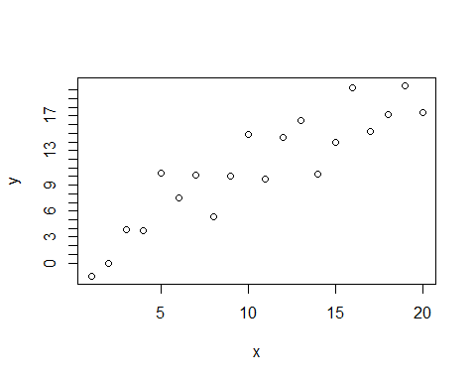

plot(y~x,xaxp=c(5,15,11)) #11 espeços no eixo x, do 5 ao 15.

